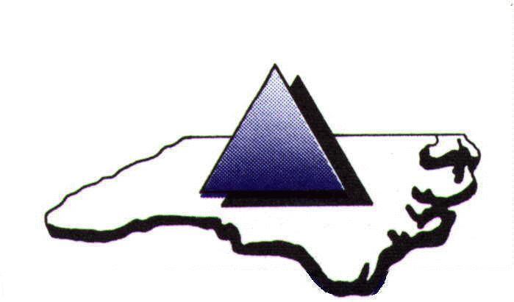

PIEDMONT TRIAD REGIONAL WATER AUTHORITY

John F. Kime Water Treatment Plant
7297 Adams Farm Road
Randleman, NC 27317

Tuesday, August 13, 2024
12:00 noon

Welcome, by PTRWA Chairman Rich Glover

- Approval of June 25, 2024 PTRWA minutes

- Approval of Deputy Finance Office Designation – Engineering Manager
Gregory Flory, Executive Director

- Approval of Commitment for Blueway / Paddleway Trail
Gregory Flory, Executive Director

- Approval of Owner’s Advisor Contract - Hazen and Sawyer
Gregory Flory, Executive Director

- Approval of PTRWA Local Water Supply Plan
Gregory Flory, Executive Director

- Approval of Grant Policies
Gregory Flory, Executive Director

- Executive Director’s Report
Gregory Flory, Executive Director

- Old Business

- New Business

- Next Scheduled PTRWA meeting date – September 10, 2024

- Adjournment

