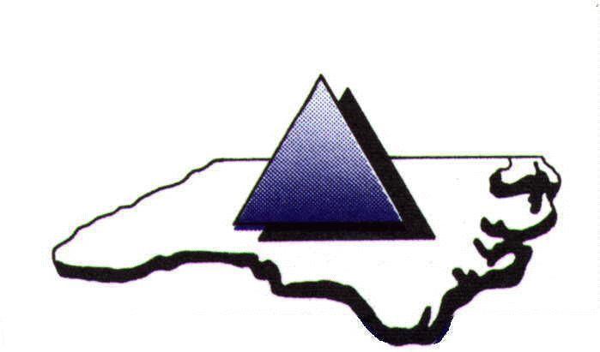

PIEDMONT TRIAD REGIONAL WATER AUTHORITY

John F. Kime Water Treatment Plant
7297 Adams Farm Road
Randleman, NC 27317

Tuesday, October 8, 2024
12:00 noon

Welcome, by PTRWA Chairman Rich Glover

- Approval of September 10, 2024 PTRWA minutes

- Adoption of Resolution Authorizing Application for North Carolina Department of Environmental Quality Division of Water Infrastructure Funding
Gregory Flory, Executive Director

- Approval to Negotiate Regional Water and Wastewater Utility Master Plan Contract
Gregory Flory, Executive Director

- Approval of Classification and Compensation Plan
Gregory Flory, Executive Director

- Appointment of Finance Director, Rebecca Brown
Gregory Flory, Executive Director

- Executive Director’s Report
Gregory Flory, Executive Director

- Old Business

- New Business

- Next Scheduled PTRWA meeting date – December 10, 2024

- Adjournment

